He knows now that he can talk to me, he can come to me, he can trust me....
“
And he really truly believes that; in the beginning, he didn’t. Big difference
to the little boy who was afraid.”
Anonymous Caregiver

CPP May Help When
- Children have been through scary or painful events such as loss of a loved person, separation, serious medical procedures, abuse, or violence at home or in the community
- Children show difficult behaviors
- Children have a change in placement or caregivers
- Family members have physical health or mental health difficulties
- Caregivers would like help with
parenting and improving parent-child relationships
“

In time we started to see...it’s ok
we can trust people, to be honest in therapy, to talk about the bad things
that happen, to feel...our sparkle inside that we thought we lost; with help we
are finding out just how bright our sparkle really is.”
Anonymous Caregiver

Who We Are

Gabby Cares of South Florida
At Gabby Cares our approach is holistic and collaborative with a primary focus on strengthening families, parents, couples, and individuals to reach their full potential. Services include: Family Therapy, Individual Therapy, Couples Counseling, Child Parent Psychotherapy, Infant Mental Health -Dyadic Therapy, Play Therapy, all through systemically working to regain a balance. Through collaboration we can work towards regaining peace and self-identified normalcy.
Contact Us
Office located at Healing Arts Institute of South Florida
(786) 501-6363
contact@gabbycaresofsouthflorida.com
www.gabbycaresofsouthfl.com

For more information about CPP visit: childparentpsychotherapy.com

Our Mission

Providing services that help young children and families
recover and heal after stressful and traumatic events

What Happens During CPP
We work together in three stages:

- Getting to Know the Child & Family
We spend time meeting alone with parents/ caregivers to understand the family’s
  - Needs and challenges
  - Strengths and values
  - History and experiences
If needed, we connect families to resources and services
We make a plan for how CPP will help your family

- Addressing Families’ Needs
We usually meet once a week with the parent/ caregiver and child
If old enough, we first help children understand
  - Who we are
  - Why they are coming
  - What we will do together
We often use toys because young children show feelings and thoughts through play
We may meet alone as adults
We help parents/caregivers and children to
  - Understand each other
  - Talk and play about difficult experiences
  - Respond to difficult feelings and behaviors
  - Create a family story that leads to healing

CPP Studies Involving Diverse Families Show

Improvements in Children’s
- Mood
- Problem behaviors
- Learning
- Trauma symptoms
- Biological stress response (cortisol)

Improvements in Parents’
- Mood
- Parenting stress
- Trauma symptoms
- Partner relationship

Improvements in Parent-Child Relationship Quality

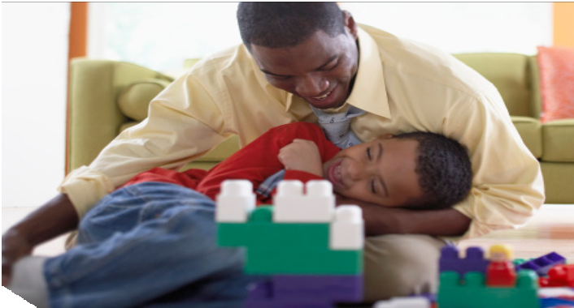
- Wrapping Up & Planning for the Future
What is CPP?
Therapy for young children
from birth through age 5 and their parents/caregivers

- Supports family strengths and relationships
- Helps families heal and grow after stressful experiences
- Respects family and cultural values
We celebrate changes families have made
We talk about how parents/caregivers made changes happen
We consider how endings and goodbyes may bring up different feelings
We talk about what will be needed in the future

You are the only one that explained how trauma is affecting my daughter and I’m so grateful.”
Adoptive Mother to her CPP Therapist
“

